I began my application by following the outlayed instructions necessary to complete the submission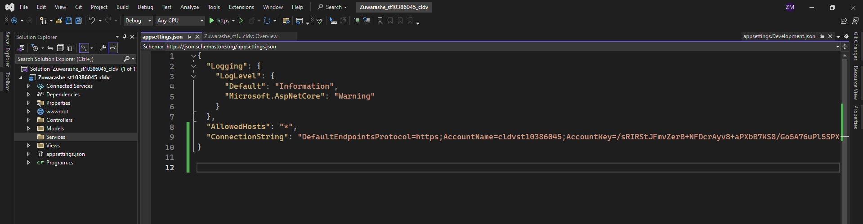

Step:adding connection string to the application

Connection string was retrieved from azure storage account made by myself using outlayed instructions

Step:I made all the necessary services files which would be needed by our application. These classes are part of a service layer in an app that connects to Azure Storage. They simplify how the app works with Azure Storage, making it easier for other parts of the app to use these services.

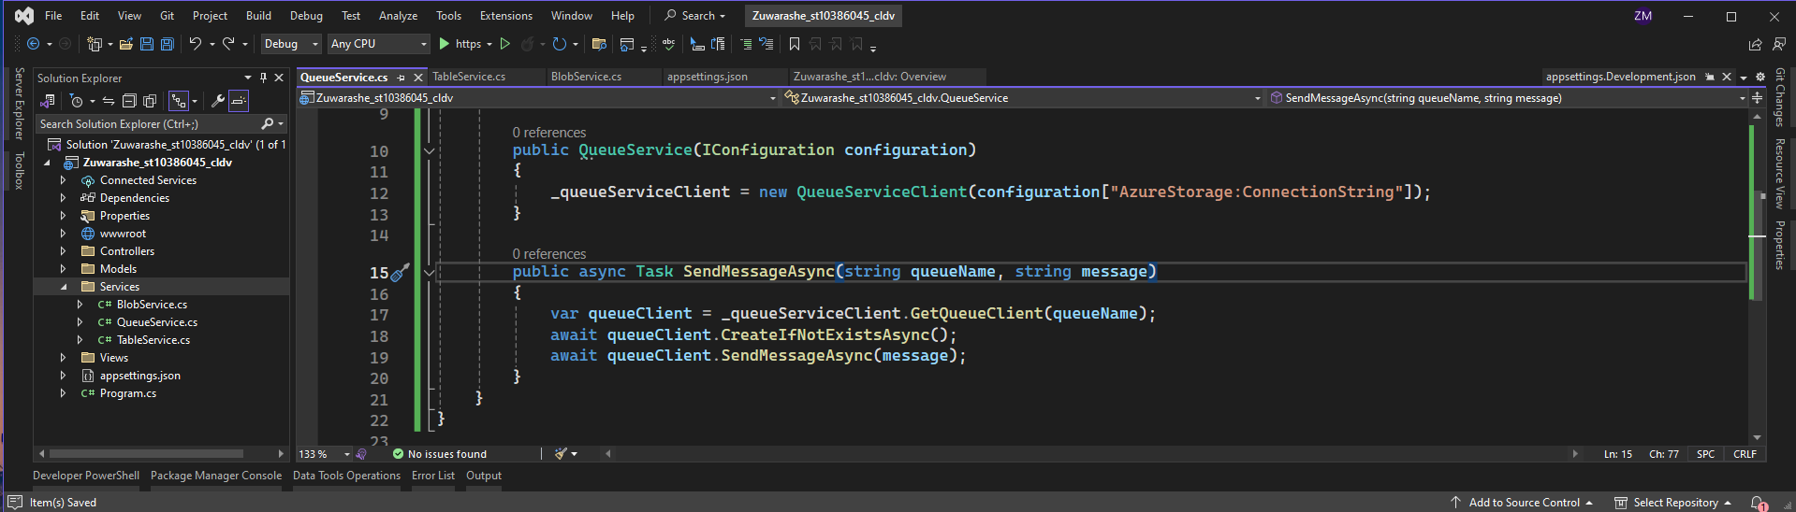

Step: I then made the model classes which are used to define the structure of the data that our application works with. They represent the entities or objects within our application's domain and map to database tables and data structures

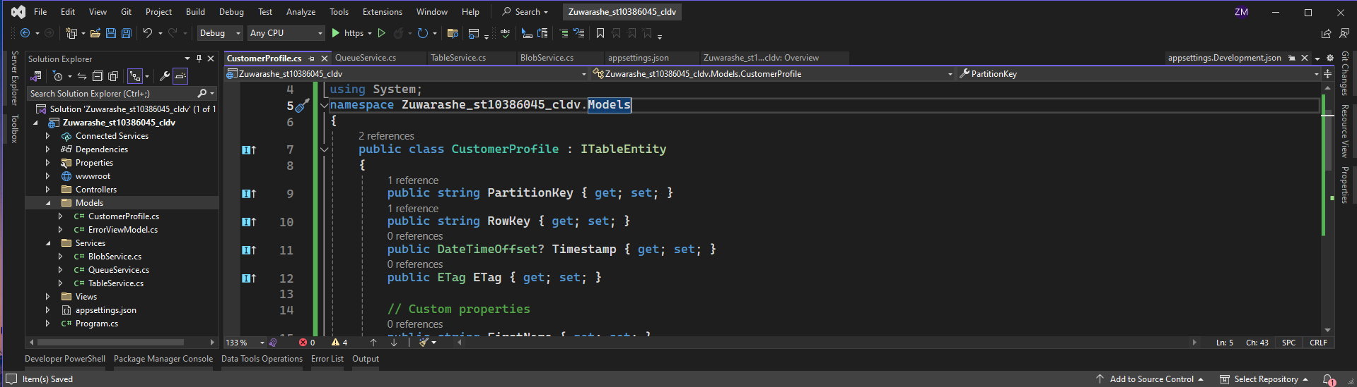

Below you will see how we made our azure data storage for our application

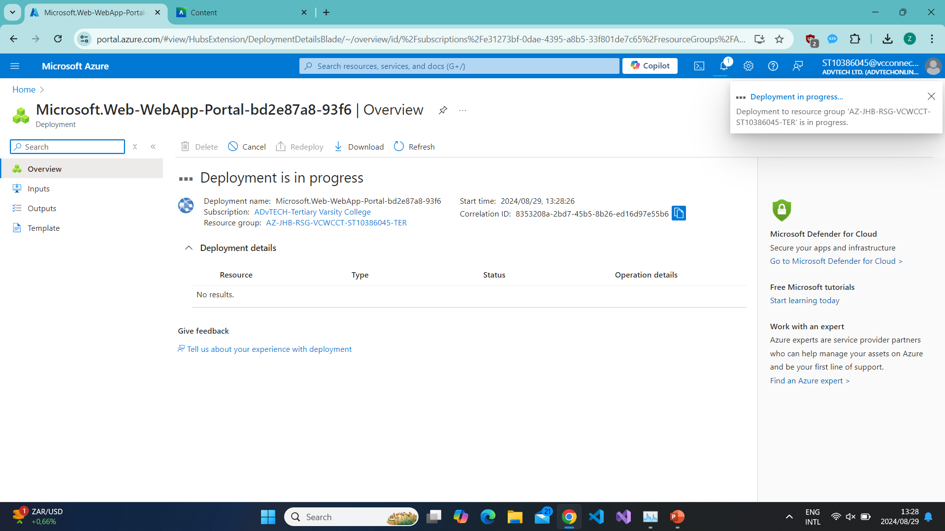

Our final application looks as follows

Here is the azure link to see 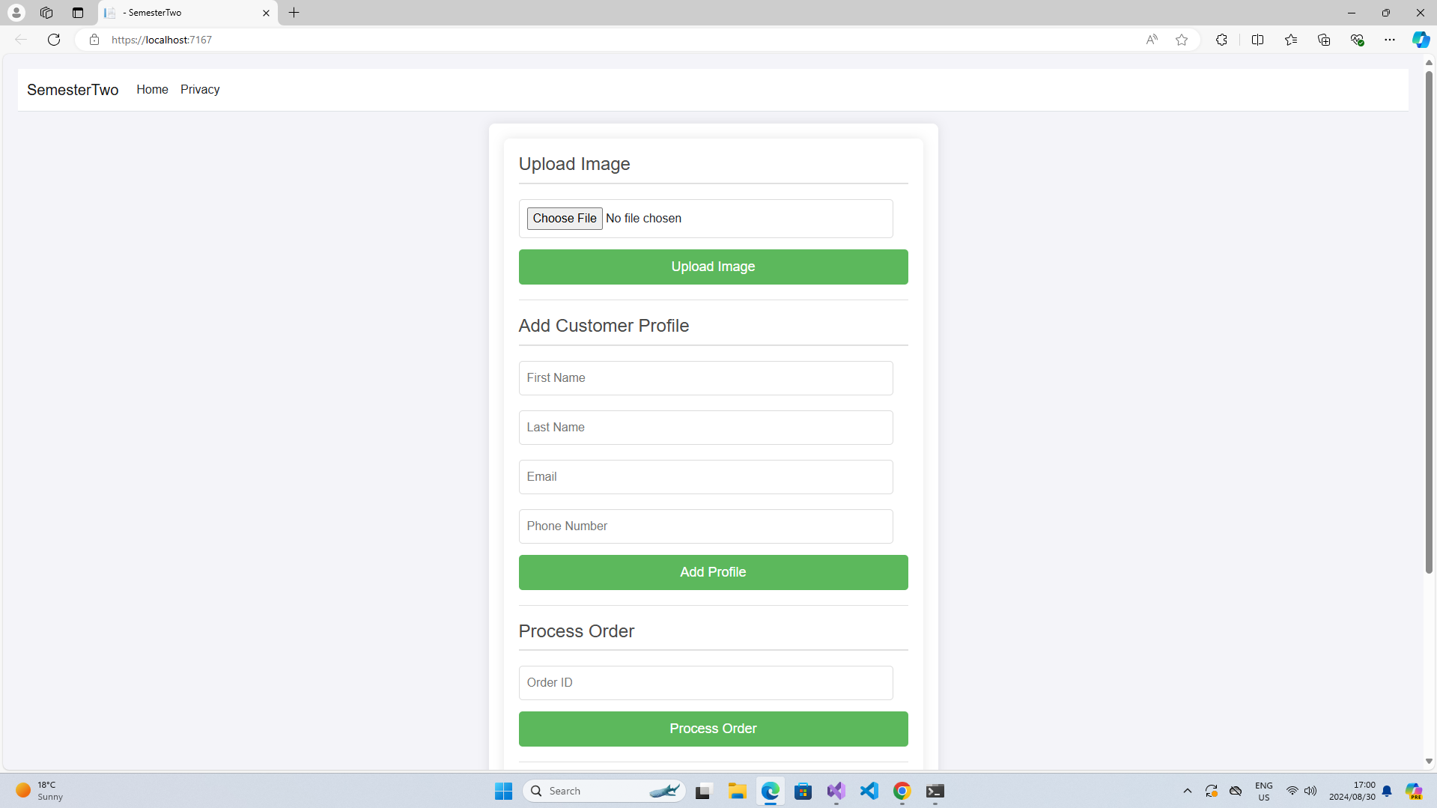

https://st10386045-hxhbh8fbemc7ayfh.ukwest-01.azurewebsites.net